**Department of Computer Science and Engineering**

**Dhulikhel, Kavre**



**Project Proposal**

**on**

**“‘NEPSE’ Stock Prediction”**

**[Code No: COMP 313]**

(For partial fulfillment of III/I Year/Semester in Computer Science)

**Submitted by**

Sashank Baral (03)

Bishal Devkota (11)

Krishna Lamsal (27)

Sulav Pokharel (32)

**Submitted to**

Mr. Nabin Ghimire

Department of Computer Science and Engineering

**Submission Date:** 18/03/2024

# **Abstract**

Forecasting stock market trends is essential for investors seeking profitable opportunities, given its status as a key economic indicator. However, the task is challenging due to the dynamic and noisy nature of market data, which poses difficulties in accurate prediction. This project aims to build a machine learning model for predicting stock prices on the Nepal Stock Exchange (NEPSE) using diverse datasets sourced from NEPSE database and floor sheets. Achieving accurate predictions requires considering multiple factors. The objective of this project is to predict stock market prices to enable more informed and accurate investment decisions.

**Keywords:** *Machine Learning, Nepal Stock Exchange (NEPSE)*

**Table of Contents**

Abstract ii

List of Figures 2

List of Tables 3

Acronyms/Abbreviations 4

Chapter 1: Introduction 5

1.1 Background 5

1.2 Objectives 6

1.3 Motivation and Significance 7

Chapter 2: Related Works 8

2.1 QuantConnect 8

2.2 Yahoo Finance 9

2.3 Merolagani 10

Chapter 3: Procedures and Methods: 11

Chapter 4: System Requirement Specification 13

Chapter 5: Project Planning and Scheduling 14

# **List of Figures**

Figure 2.1.1: QuantConnect 12

Figure 2.2.1: Yahoo Finance 13

Figure 2.3.1: Merolagani 14

# **List of Tables**

Table 5.1: Gantt Chart 19

# **Acronyms/Abbreviations**

ML Machine Learning

NEPSE Nepal Stock Exchange

EDA Exploratory Data Analysis

# **Chapter 1: Introduction**

## 1.1 Background

The increasing significance of stock price prediction has gained attention from both expert analysts and investors. However, forecasting market trends proves challenging due to inherent noise and high volatility within the market environment. The complexities of stock prices are influenced by various factors, including quarterly earnings reports, market news, and shifting behaviors. Traders rely on daily-collected technical indicators to analyze stock returns, yet forecasting daily and weekly trends remains complex.

Accurately predicting stock trends is both compelling and complex in today's evolving industrial landscape. Economic and non-economic factors play pivotal roles in shaping stock trends, presenting a significant challenge for production growth. Traditional methods often rely on past stock returns, financial variables, and macroeconomic indicators to forecast market earnings. However, this approach prompts investors to investigate the underlying causes of predictability. Forecasting stock trends is further complicated by factors such as trader expectations, financial circumstances, regulatory events, and market-related aspects. Moreover, the dynamic, complex, noisy, nonparametric, and nonlinear nature of stock price lists presents additional challenges. Financial time series forecasting is hindered by complexities such as volatility, irregularities, noise, and shifting trends.

Therefore, the objective of this study is to try and predict the future stock market prices by using the existing methodologies such as regression or continuous learning and further try to modify them by analyzing the recent trends of various research.

## 1.2 Objectives

The main objectives of this project are:

1. Build an efficient model for stock prediction
2. Conduct Technical and Fundamental Analysis of stock market
3. To identify irregularities and potential manipulation in the stock market.

## 1.3 Motivation and Significance

The motivation behind this project stems from the need to address the complexities inherent in stock market prediction, particularly within the context of the NEPSE. By exploring and implementing various machine learning algorithms, we aim to enhance the accuracy and reliability of stock price predictions on the NEPSE.

Furthermore, this project seeks to contribute to the existing body of knowledge in stock market prediction by conducting a comprehensive analysis of recent trends and advancements in the field. By examining different types of machine learning classifiers and their variants, we endeavor to identify the most effective approaches for predicting stock prices on the NEPSE.

The significance of this project lies in its potential to provide investors with valuable insights and tools for making informed and strategic investment decisions in the Nepalese stock market. By predicting future stock market prices more accurately, this project aims to empower investors to navigate the complexities of the NEPSE with greater confidence and precision, ultimately facilitating the growth and stability of the Nepalese economy.

# **Chapter 2: Related Works**

As the research for the project proceeded further, we went on to find some projects

with goals like our own. Three such projects stuck out as noteworthy each of which

is described in brief below:

## 2.1 QuantConnect

Figure 2.1.1: QuantConnect

QuantConnect [4] is a cloud-based algorithmic trading platform that provides stock prediction models based on machine learning algorithms. Its key features include a powerful backtesting engine, support for multiple programming languages, and access to a vast library of financial data. Users can design, test, and deploy trading strategies using QuantConnect's platform.

**Key Features:**

* Cloud-based algorithmic trading platform.
* Backtesting engine for testing trading strategies.
* Stock prediction models based on machine learning algorithms.
* Support for multiple programming languages and financial data sources.

## 2.2 Yahoo Finance

Figure 2..1: Yahoo Finance

Yahoo Finance [5] provides comprehensive stock market data, news, and analysis. It offers stock prediction tools powered by machine learning algorithms, along with historical data and interactive charts for technical analysis.

**Key Features:**

* Comprehensive stock market data, news, and analysis.
* Stock prediction tools powered by machine learning algorithms.
* Historical data and interactive charts for technical analysis.
* Customizable watchlists and portfolio tracking.

## 2.3 Merolagani

Merolagani [6] is a popular online platform in Nepal for stock market analysis, news, and trading. It offers a range of features and tools to help investors make informed decisions in the Nepalese stock market.

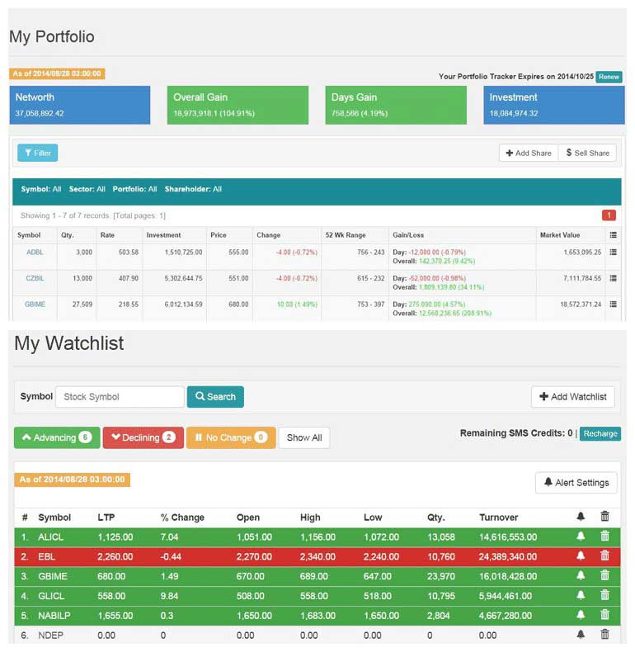

Figure 2..1: Merolagani

**Key Features:**

* Real-time and historical data on stock prices, indices, and market trends on the Nepal Stock Exchange (NEPSE).
* News articles, analysis, and expert opinions on the Nepalese stock market.
* Technical analysis tools including interactive charts, technical indicators, and pattern recognition.

# **Chapter 3: Procedures and Methods:**

Our project follows a structured sequence of procedures considering all the parameters of data engineering before validating it with machine learning models. The procedure used to accomplish the target is presented and discussed in various steps as follows:

**Data Collection:** The initial step involves gathering historical stock market data from the Nepal Stock Exchange (NEPSE). Additionally, web scraping techniques are employed to collect real-time data from financial news websites, social media platforms, and other online sources. This comprehensive approach ensures access to diverse datasets containing information on stock prices, trading volumes, and other relevant variables.

**Data Preprocessing:** Following data collection, a meticulous preprocessing phase is undertaken. This involves cleaning the collected data to remove any inconsistencies, missing values, or outliers. Furthermore, data normalization or scaling techniques are applied to ensure uniformity across different features. Finally, the data is split into training and testing sets to facilitate model development and evaluation.

**Exploratory Data Analysis (EDA):** Once the data is preprocessed, exploratory data analysis (EDA) is conducted to gain insights into its characteristics and patterns. Through visualization techniques such as charts, graphs, and statistical summaries, trends, correlations, and anomalies are identified. This phase plays a crucial role in informing subsequent modeling decisions.

**Feature Engineering:** Feature engineering is a key step aimed at enhancing the predictive power of the models. Relevant features that may impact stock prices, such as technical indicators, economic indicators, and market sentiment, are identified. Additionally, new features are engineered or existing features are transformed to further improve model performance.

**Model Selection:** A variety of machine learning algorithms are experimented with during the model selection phase. Each model is evaluated using appropriate metrics such as accuracy, precision, recall, and F1-score to determine its performance.

**Model Training and Hyperparameter Tuning:** Selected models are trained using the training dataset, with hyperparameters tuned as necessary to optimize performance. Cross-validation techniques are implemented to ensure the robustness of the models and mitigate overfitting, thereby enhancing their generalization capability.

**Model Evaluation:** The trained models are evaluated using the testing dataset to assess their predictive accuracy and generalization capability. Comparative analysis is performed to gauge the performance of different models and methodologies based on predefined evaluation metrics.

**Prediction and Analysis:** Utilizing the best-performing models, stock market predictions are generated on unseen data. Subsequent analysis aims to identify trends, patterns, and potential irregularities or manipulation in the stock market, providing valuable insights for decision-making.

**Validation and Interpretation:** The accuracy and reliability of the predictions are validated against real-world market conditions. Results are interpreted to derive actionable insights and implications for investors and stakeholders, facilitating informed decision-making.

**Documentation and Reporting:** The entire process, including data preprocessing steps, model development, evaluation metrics, and analysis findings, is meticulously documented. A comprehensive report is prepared, summarizing the project objectives, methodologies, results, and recommendations for future research or investment strategies.



# **Chapter 5: Project Planning and Scheduling**

**Gantt Chart**

The following is the gantt chart to show the time allocated and planning for different aspects of our project:

|  |  |  |  |  |  |  |  |  |  |  |
| --- | --- | --- | --- | --- | --- | --- | --- | --- | --- | --- |
| Weeks | 1 | 2 | 3 | 4 | 5 | 6 | 7 | 8 | 9 | 10 |
| Planning |  |  |  |  |  |  |  |  |  |  |
| Proposal Writing |  |  |  |  |  |  |  |  |  |  |
| Data Collection and preprocessing |  |  |  |  |  |  |  |  |  |  |
| Prediction, Analysis and Interpretation |  |  |  |  |  |  |  |  |  |  |
| Documentation |  |  |  |  |  |  |  |  |  |  |

Table 5.: Gantt Chart

**References**

1. Sharma, S., & Kaushik, B. (2017). Quantitative analysis of stock market prediction for accurate investment decisions in future. *Journal of Artificial Intelligence*, *11*(1), 48–54. https://doi.org/10.3923/jai.2018.48.54
2. Gandhmal, D. P., & Kumar, K. (2019). Systematic analysis and review of Stock Market Prediction Techniques. *Computer Science Review*, *34*, 100190. https://doi.org/10.1016/j.cosrev.2019.08.001
3. C. Boobalan. (2014). *TECHNICAL ANALYSIS IN SELECT STOCKS OF INDIAN COMPANIES*.
4. *Design and trade algorithmic trading strategies in a web browser, with free financial data, cloud backtesting and capital - quantconnect.com*. Design and trade algorithmic trading strategies in a web browser, with free financial data, cloud backtesting and capital - QuantConnect.com. (n.d.). https://www.quantconnect.com/
5. Yahoo! (n.d.). *Yahoo Finance - Stock Market Live, quotes, Business & Finance News*. Yahoo! Finance. https://finance.yahoo.com/
6. *Nepal Stock Exchange (NEPSE) News, live trading, live floorsheet, indices, company announcements and reports, market analysis, online portfolio tracker, Watchlist, Alerts, Investor Forum*. merolagani. (n.d.). https://merolagani.com/Index.aspx